Dunnottar Primary

We Shine

Positive Relationship Policy

“GETTING THE CULTURE RIGHT IS PIVOTAL. With the right culture the strategies that are used become less important. The culture is set by the way the adults behave.” Paul Dix

“But why crush behaviours with punishment when you can grow them with love? VISIBLE CONSISTENCY WITH VISIBLE KINDNESS ALLOWS EXCEPTIONAL BEHAVIOURS TO FLOURISH.” Paul Dix

Dunnottar Primary School Positive Relationship Policy
Date policy agreed: | Date of next review: | Headteacher signature: | Parents signature:

Our Why
Our children have a right to an excellent education
Our children have the right to be safe.
Our children have the right to be valued as an individual.
Our children have a right to play.
Our children have a voice.

Vision, Values and Aims

Our vision, our values and our rights underpin all our policies and the education we deliver. Article 3 of the United Nations Convention on the Rights of the Child states that: The best interests of the child must be a top priority in all decisions that affect children. This policy has been created to keep the children at Dunnottar School safe and happy, igniting a love of learning that will last a lifetime.
At Dunnottar Primary School “We Shine”. This motto is underpinned by our four values:

We are WELCOMING  - Equity  - Diversity  - Inclusion  - Choose Kind | We are DETERMINED  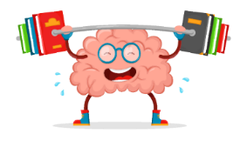  - Perseverance  - Resilience  - Overcome Barriers  - Challenge Yourself
We are RESTPECTFUL  - Rights Respecting  - Cooperative  - Be Helpful  - Be Responsible | We EXPLORE  - Growth Mindset  - Outdoor Learning  - Visible Learning  - Our Wider Community

Application of the Policy
The policy applies to all staff employed by the school.

Purpose
This policy sets out the framework for a clear and consistent approach to promoting positive relationships and engage pupils to support their skills and understanding and engagement with school. It promotes an ethos of empathy and understanding of all our children and young people, and their families.
It teaches children and their families about their rights and how actions can affect the rights of others, underpinned by the United Nations Convention on the Rights of the Child and wellbeing indicators – in line with ‘Getting it Right for Every Child’; Scotland’s national approach for improving outcomes for learners.
SAFE HEALTHY ACTIVE NURTURED ACHIEVING RESPONSIBLE RESPECTED INCLUDED

Aims
At Dunnottar School, it is expected that every member of the school community feels valued and respected, and that each person is treated fairly. We are a caring community, whose values are built on mutual trust and respect for all. The school’s Positive Relationships Policy is designed to support the way in which all members of the school can work together in a supportive way. It aims to promote a positive and emotionally healthy environment in which everyone feels happy, safe and secure – because when we do, WE SHINE.

The Positive Relationships Policy is a means of promoting relationships where we understand each other, enabling everyone to work together with the common purpose of helping all pupils to achieve their best. This policy supports the school community (parents/carers, staff and children) in aiming to allow everyone to work together in an effective and mindful way.

The school expects every member of the school community to behave in a considerate, cooperative and respectful way towards others. Pupils should be treated impartially and with the Positive Relationships Policy being applied in a consistent and attuned way.

It aims to help pupils to grow in a safe and secure environment, and to become positive, responsible and increasingly independent members of the school and the wider community. It is designed to recognise, encourage, and promote positive behaviour. In part, through the ongoing development of pupil emotion regulation.

Rationale
At Dunnottar School we recognise that behaviour is communicative and often reflects an emotion or feeling. Our Positive Relationships Policy is grounded in the belief that we are able to develop our ability to self-regulate our emotions and behaviour. Adult and child relationships are integral for this to occur. Through co-regulation of feelings, children learn to become more independent and develop self-regulation.

Staff Responsibility
Developing supportive relationships with pupils is the responsibility of all members of staff. Staff will seek to understand the pupils’ perspective of the situation, strive to understand the child’s feeling whilst maintaining a consistent, sensitive, and firm but fair limits on behaviour. Staff will help pupils to develop a range of strategies to manage expectations, including the social skills needed to interact positively with others, but are also skilled in acknowledging that children have individual needs and therefore may benefit from differentiated interventions and support.

The Role of Parents and Families at Dunnottar School

We value parental partnerships and encourage early involvement of parents and carers in building positive relationships supporting the rights of every child and positive behaviour. Parents agree to a Home School Agreement when enrolling their child at the school. The expectations are that parents adhere to the Home School Agreement and support the actions of the school.

Open Door Policy
Parents can address any queries regarding arising concerns, Emotion Coaching, co- and self-regulation, and restorative approaches firstly to the class teacher, then to the Head Teacher. The initial communication can be made through emailing the school office at Dunnottar.sch@aberdeenshire.gov.uk who will acknowledge your email and pass it on to the correct person. We will respond to you within 2 working days. Parents are welcome to come to the school office to request to talk with a member of staff but should be prepared to make an appointment if that member of staff is not available. Appointments can be made in person, by telephone or via Teams.
We aim to work with parents to achieve a shared approach and consistent messages between home and school to support their child’s emotional and behaviour development.

Promoting Pupil Engagement and Self-Regulation
Class Expectations

Class expectations are generated by the pupils through the Class Charter. They are displayed in each classroom and should be revisited with the pupils at the beginning of each term and at other times when necessary. Class teachers, support staff and pupils devise these at the beginning of the academic year. They are intended to be guidelines of behaviour expectations that both pupils and adults would like to see in their classroom. They should focus on the positive rather than the negative.

All classes use Circle Time sessions and Restorative approaches as tool for promoting positive behaviour and resolving low level behaviour. Circle Time sessions may be combination of games and opportunities for children to respond positively to each other in a safe, friendly environment. Restorative conversations and approaches also provide the class with an opportunity to discuss and reflect upon situations that have been difficult to manage, to then consider ways in which the situation can be managed more successfully in future.

Positive awards are available for pupils throughout the day. These aim to promote confidence, competency, motivation, help pupils to develop growth mind-sets and promote prosocial behaviour. These include:
- Positive recognition boards feature in all classes and are used to ensure children are given positive recognition throughout the school day. These are aimed at our values and engagement.
- House Points Every child at Dunnottar School belongs to a house; Ruby, Amber, Emerald and Sapphire. The children can earn house points for improvement and challenging themselves, demonstrating the school’s values and for good sportsmanship and teamwork. The house points are counted weekly, where there is a celebration in assembly for the winning team that week. The winning house gets a reward each half term
- Sharing work with other teachers and the Head Teacher
- Achievement assembly certificates Every week a child from each class is nominated to receive an achievement award.
- PSA Award – counted at assembly and the winning class gets 10 minutes of extra play time.

Emotion Coaching

We use Emotion Coaching to support children to understand, regulate and reflect on their behaviour.

To help children learn to understand how a feeling relates to an emotion, children are encouraged to reflect on which Zone of Regulation they are in.

Emotion Coaching

Step 1

Recognising the child’s feelings and empathising with them.
Step 2

Label the feelings and validating them
(
validating = let the child know why they might be feeling like this and that this is okay.
Step 3

Set limits on the behaviour (if needed)
Step 4

Problem-solve with the child

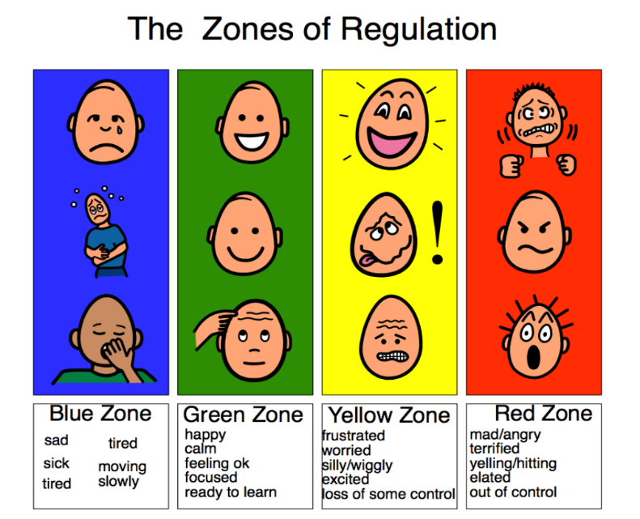
Zones of Regulation

Emotion Coaching Provision Map

All staff wear a lanyard attachment which outlines the steps of Emotion Coaching and the Zones of Regulation to support conversations with children.
The relationship a class teacher forms with children is central to the learner’s personal, social and emotional development. Class teachers are expected to use a range of approaches set out in the provision map to support the development of learner self-regulation, as set out below.

Nurturing and Restorative Approaches
Restorative approaches help teachers ensure that pupils, staff and parents can be part of a fair process, while helping all involved to understand the impact of their actions on others.
Key principles of Restorative Approaches
- A growing responsibility for one’s own actions and their impact on others
- Respecting other people, their views, and feelings.
- Understanding our own feelings and the feelings of others.
- Being fair
- Everyone in school being given appropriate opportunity to be involved in decisions about their own lives.
- Exploring issues of conflict with participants in a supportive environment
- Willingness to create opportunities for reflective change in pupils and staff

Restorative Approaches can:
- Ensure outcomes that are meaningful to the situation that has arisen
- Help develop a whole school positive ethos
- Encourage children to effectively resolve and learn from conflict in a positive way
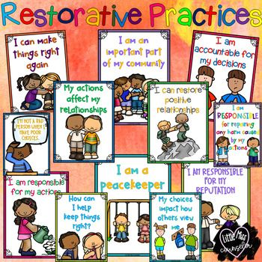

Teachers work collaboratively with each other. Pupil Support Staff have guidance on how to support the activities in Olly’s Oasis through training and partnership working with teachers, parents and agencies as required.

TEACHERS
Modelling
emotion
socialisation
IN CLASS
Anticipating and
preparation of
feelings
Emotion
Coaching

Restorative
chat

Olly’s Oasis
Quiet space to complete task.
Return to class once complete.

OUT OF CLASS
Olly’s Oasis
Return to class for next lesson.

Olly’s Oasis

Room – quiet time.
Restorative
conversation
with other
member of staff
(Head Teacher)

Physical calming or
grounding activity with an
adult

Emotion Coaching | Olly’s Oasis | Restorative chat / Reparation
- Noticing, being aware of pupil feelings and empathising with them  - Labelling and validating pupil feelings  - Set limits on behaviour  - Help pupil to problem solve | - Physical, grounding and calming (upregulation)  - Developing emotional awareness  - Developing reflection skills (see in manual) | What happened?  Who was affected?  What were you feeling?  (Emotion Coaching might be required.)  What were others involved feeling?  How can we make things right?

Monitoring and reporting behaviour patterns
All teaching staff can record behaviour using our online monitoring system. This system is monitored by the Head Teacher. Any behaviour patterns emerging are considered and strategies are implemented and adapted to suit the children’s needs. We may involve parents at this stage for consultation or support.
Concerns arising in the playground are recorded and discussed at PSA Meetings which occur monthly and ad hoc, depending on the needs arising.
Patterns, trends, actions and impact are recorded termly.
Support for adults to ensure consistency:
All new staff attend induction training during which includes the ethos of our school, and this policy is outlined and explained along with Emotion Coaching. All staff have received training which is reviewed regularly. Supply or short term staff are inducted into school systems on arrival through the class supply information sheet. Staff get feedback on learning and other forms of pupil encouragement and engagement and motivation in lesson observations and sharing best practice with colleagues.
All staff are encouraged to take responsibility for their own development in this area and to seek support/guidance where they feel a need is arising.

Additional Needs
We acknowledge that some pupils’ behaviour may reflect social, emotional and mental health needs which may require additional provision to what is outlined in this policy. The Additional Support for learners policy should be read for how additional needs are supported in the school.

Exclusion
In our school it is rare that school support will not have a positive impact upon pupil behaviour development and regulation. However, the school does and will exclude pupils for persistent abusive or violent behaviour or repeated and escalating low level disruptive behaviour.
It is our ethos that we will make every provision for a child to achieve socially and emotionally but if, in spite of this, behaviours are risky, unsafe, violent and prevent the efficient education of others, fixed term or permanent exclusion may be applied.
We abide by local and national guidance on this and report any exclusions routinely to Aberdeenshire Council.

Risk assessment
At times at Dunnottar School it may be necessary to conduct a risk assessment for the particular behaviour displayed by a child. We will attempt to reduce risk by managing:
- The environment
- Our body language
- The way we talk to the children
- The way we act
- And by personalising curriculum and other learning programmes
Our staff have been trained in the Crisis, Aggression, Limitation and Management (CALM) Theory training programme.
One of the hardest things is knowing what to do when those you work with are experiencing real distress and behaving in a way that challenges your ability to support them.
The CALM’s Core Theory Course helps us understand behaviours that challenge, and how to reduce – and prevent – those behaviours over time.
By providing attachment based and trauma informed positive behaviour support (PBS). Our whole staff can reflect on and explore their everyday work practice and how this aligns to best practice principles based on theory and professional frameworks. Whole person support plans, based on an individualised assessment, are now commonly developed.

Policy Links

National and Local Context

United Nations Convention on the Rights of the Child (1989)
At Dunnottar School we strive to develop policies and procedures which aim to improve relationships and take into account the rights of children as set out in the UNCRC. This includes the right to be safe, have a good quality education and to develop friendships. Upholding these rights as well as broader human rights is central to this guidance document.

Curriculum for Excellence: Health and Wellbeing Across Learning: Responsibilities of All (2014)
On a day to day basis, our practitioners within the nursery and school are responsible for supporting the development of positive relationships through the delivery of the Curriculum for Excellence. As part of this, staff are responsible for the planning of specific experiences and outcomes within the Health and Wellbeing Curriculum. All staff have responsibility for promoting positive relationships among children and young people through the relationships experiences and outcomes.

Getting it Right for Every Child sets out the responsibility of staff to consider the wellbeing of all children and young people. The wellbeing of each child can be considered using the wellbeing indicators to ensure children feel safe and are healthy, achieving, nurtured, active, responsible, respected and included. Some children and young people will require more targeted/individual approaches to develop positive relationships and achieve their potential.
Antibullying Guidance (asn-aberdeenshire.org)
This guidance was originally shaped by the Youth Commission who were a group of young people tasked with developing an anti-bullying policy and guidance. They worked with an advisory panel who to address their aims.

The Equality Act (2010)
The Equality Act (2010) places a duty on local authorities to promote equality of opportunity for all and to progress equality in particular for those with a protected characteristic as outlined in more detail in section four. It places a duty to foster good relationships with those who have a protected characteristic and those who do not.

Education (Additional Support for Learning) (Scotland) Act (2009)
The amended Education (Additional Support for Learning) (Scotland) Act (2009) outlines the wide variety of circumstances which may give rise to additional support needs. This places a duty on all education authorities to identify such needs and plan and review appropriately.

Developing a Positive Whole School Ethos and Culture: Relationships, Learning and Behaviour (2018)
Developing a Positive Whole School Ethos and Culture: Relationships, Learning and Behaviour (2018) concludes that a positive school ethos and culture (sometimes described in research as ‘climate’) is essential to developing good relationships and positive behaviour in the classroom, playground and wider community.

How Good is Our School (HGIOS4) (2015) and How Good is our Early Learning and Childcare (HGIOELC) (2016)
How Good is Our School (HGIOS4) (2015) and How Good is our Early Learning and Childcare (HGIOELC) (2016) provide a framework for establishments to evaluate and reflect upon their own individual successes and capacity for improvement. Quality indicator 3.1 focuses on wellbeing, equality and inclusion. Involvement of parents and carers as part of this reflection is vital.

Policy Review Process

Dunnottar Primary School’s Promoting Good Relationships and Behaviour Policy states that “This policy functions as a practice guide and is therefore reviewed whenever issues arise which generate new ways to articulate our approach, and otherwise annually”.

