

**Dunnottar**

**Nursery**



**Newsletter**



**October 2022**



‘



We

explore



Term 2 starts

**Dates for**

**your diary**

**Mon 31st**

Halloween

celebration

**Mon 14th Nov**

World kindness day

**Mon14th**

Book week

**17th – 18th**

**In service**

Nursery closed

**Wed 30th**

St Andrews day

**Mud glorious mud!**

**Nursery staff have been participating in Virtual Nature School training since the beginning of September. It is a nature-based training course that encourages children and staff to explore the outdoors to support and extend children’s learning and developmental interests!**

**Thank you for the donations of natural materials, you will have noticed an increase in architectural and structural exploration as the children and staff explore ways in which these can be used! We have also been exploring sensory nature through water, mud and sand which of course leads to the inevitable clothing changes! A set of waterproof trousers or dungarees definitely help! Through this exploration we have been looking at the concepts of design, change, mixing and properties as well as art and design! Such a lot of wonderful learning and wonderful language development too, great job kids!!**

**Debbie Henderson**

Why didn’t the skeleton go to the Halloween party this year?

Because he had no body to go with!

Happy

Holidays!!

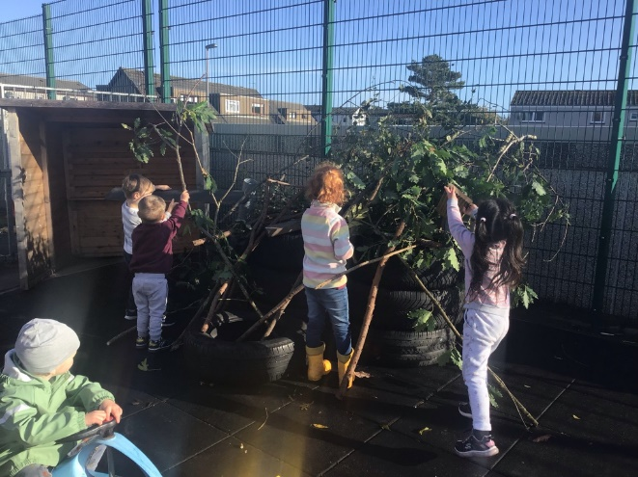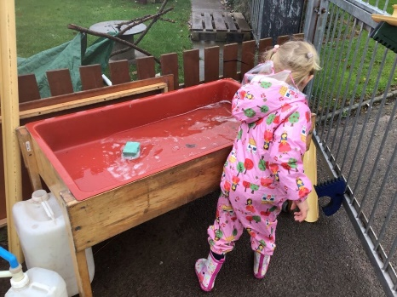

**Halloween party**

**Monday October 31st**

Come dressed in party clothes or Halloween dress up!

Children have been talking a lot about costumes lately!

**Welcome!!!**

This session we have welcomed

**Mrs McGrath** to our nursery staff, she is throwing herself into nursery life and enjoying the outdoor explorations enormously with the children.

We have also welcomed **Miss Spence** who is joining us from NESCOL as an HNC student for this year. She will be with us twice a week throughout the year and also spending a few full weeks to fully embrace nursery life as she works towards her qualification.

The children have been enthusiastic in their welcome and are enjoying sharing their nursery adventures with them!

**Transition survey**

Thank you to those who came along to the ‘Play and Learning’ evening. We hope that the session was interesting and useful.

This session was the last event in our transition calendar, and we would now like to invite you to undertake a quick survey to help our evaluation.

Please [click here](https://forms.office.com/r/S9nFY3u3y2) to tell us ‘How we did’.

**Feedback will be used to develop next year’s transition and settling process.**

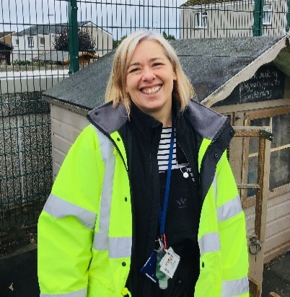

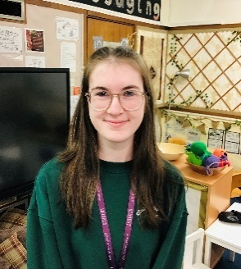



We are

welcoming



**Nursery improvement plan**:

As part of this year’s improvement staff are evaluating the children’s lunchtime experience. We have been making changes to the routine and way in which children are served their meals so that the experience affords children opportunities to develop language and communication skills in a social context. The processes involved in preparation of mealtimes, nurture respect and responsibility through setting up, eating and clearing away

**Recent changes to our routine:**

* Introduction of lunch helpers with set roles and responsibilities
* Helper ‘picture menus’ as a visual to support children’s understanding of ‘how to set the table’
* Serving our own lunch
* Encouraging children to make friends, showing respect and manners as we work together or while wait for each other before clearing our table

You can encourage these skills during meal and snack times at home!

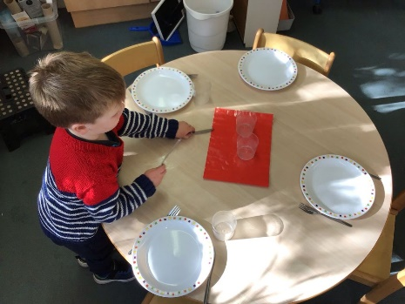

We

respect



**What children have told us….**

“I choosed everything because I like macaroni, peas and the little potatoes. I get to take some more if I want to.”

“I like choosing, I can have the things I like and not have macaroni, I don’t like macaroni.”

**Exploring our values**

Staff have been exploring ‘language of our values’ with the children over the last few weeks. We would like to create a display within the nursery with your help, looking at ways in which the children explore, discover, unearth, delve into, and investigate within their daily routines and experiences!!!

Over the holidays we would like you to EXPLORE and see what signs of Autumn you discover! Please collect any materials, evidence that can safely be scavenged so that you can share them once we return from the holidays. We would also appreciate photographs of any interesting finds or new experiences.

**After the October holidays we will be introducing the new Aberdeenshire Autumn menu. The updated menu can be** [**accessed here**](https://www.aberdeenshire.gov.uk/schools/school-info/meals/primary-school-meals/)**, at the beginning of Term 2.**

**In-Service days**

**Please note that the 17th and 18th of November are in-service days and the nursery will be closed to pupils.**



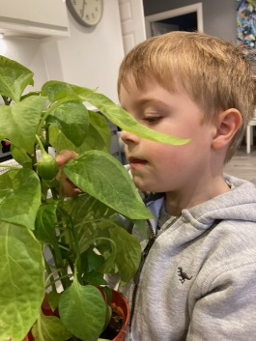

**We Shine**



We are

determined



**If you have a ‘Shining example’ of your child having a go, trying something new or a first success then please send them along by email to be included in their Seesaw profile. They may even feature in our newsletter!**

**William shines with his new project!**

William wanted to share his success with his friends and the nursery staff. He has persevered growing a pepper at home and it is doing very well! William has been taking very good care of his pepper plant and now…… it is beginning to grow a pepper! He is hoping that it will keep growing ready for picking! I wonder what he will make with it when it is finally picked?

**Fantastic job William**, we are all very proud of you. 😊