

**Dunnottar**

**Nursery**



**Newsletter**



**August 2022**



We are

welcoming

**Dates for**

**your diary**

**Wed 21st**

International Day of Peace

**Tues 9th**

Teddy bear day

**Tues 13th**

Roald Dahl day

**Mon 19th**

Talk like a Pirate Day

**Drop off and pick up:**

As we move closer to our new starts beginning regular session attendance next week, we would like to highlight our usual nursery drop off and collection routines.

Arriving children are collected by staff in the morning from the gate entrance to nursery and will be brought back to the gate for collection. This supports the children in mastering nursery morning and end of day routines independently and usually leads to smoother transition. However, there are occasions when children are unsettled or require additional parental support, staff will invite you into the garden or nursery to help children settle where this is required.

Children are encouraged to take their bag into the classroom and then may return to the garden to play should they wish.

**Welcome to the first of your Nursery Newsletters!**

**Firstly, I have to say it has been lovely to see all our children so excited to be in the nursery setting, embracing the chance to explore our lovely new environment. Staff have all remarked how settled and busy the children have all been. They have been excited to share all their adventures too! It has been equally lovely to see how welcoming and supportive our returning children have been in helping our new children, showing them around and encouraging them to explore and play in their new surroundings. A huge well done to you all!**

**I know that this year will bring lots of new adventures as we move outwards back into the community and encourage you to join in again wherever possible!**

**Debbie Henderson**

**We Shine**

As a security measure staff ask that you do not open the gate if you are early or late, as this creates unnecessary risk. If staff and children are in the garden area, they will be able to meet you at the gate. If there is no one in the garden, then please knock on the nursery window for attention.

**Our Family wall**

We are developing a ‘my family’ wall in the nursery and ask that you have a chat with your child and bring in any photographs that show your child and family for display. The inclusion of family photographs into nursery supports respectful discussion surrounding the diverse nature of our families throughout the year.

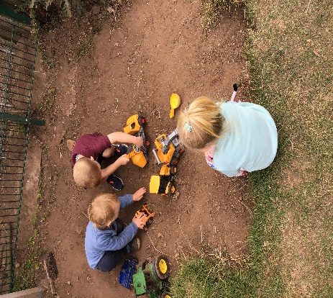

**Stay and Play sessions WB 19th September**

Stay and Play sessions will be available throughout the week from Monday 19th September, sign up sheets will be available to book a slot from the 12th September! Book early to ensure that you can fit around your schedule!

We

respect



**Parent Engagement**:

We are developing several opportunities over the course of the year to ensure that parents and families are included within nursery life.

These include but are not restricted to:

* Opportunities to participate in story time, trips &baking among others
* Volunteering on trips into the community
* Stay and play sessions
* Skills sharing sessions – let us know if you have hidden talents to share!

Let us know if there are other ways you feel you can be involved, we always welcome feedback!

**‘Eat a Rainbow’ Healthy Eating focus!**

Over the course of this year children will be encouraged to try a range of different coloured fruits and vegetables to broaden awareness of healthy eating and how we can adopt healthy lifestyles. To that end there will be lots of discussion throughout the nursery day, stories and prompts to support children’s developing knowledge as well as opportunities to taste and try a range of fruit and veg! Children will be able to help create snack menus as we move forward and hopefully, they will ‘Eat a Rainbow’ before the end of the session!

You can help by supporting this at home and sharing any achievements or new experiences!

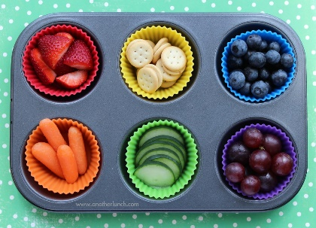

**Teddy Bear Day**

Friday the 9th of September is Teddy Bear Day! Children are invited to bring along their favourite teddy to participate in songs and games throughout the day to celebrate!

‘



We

explore

**Nursery request!**

The nursery is currently looking for any surplus art and craft materials to encourage children’s exploration of materials, arts and craft activities. This includes but is not limited to:

**Ribbons,**

**Collage materials**

**Sweet papers**

**Buttons**

**Small junk modelling items**

**Cardboard tubes (all sizes!)**

**Stickers**

**Wool**

Essentially if you or your child find it interesting, we are happy to explore it!

**School Values**

Staff are working with the children to embed our new values throughout nursery, we appreciate you sharing them at home too wherever possible!

**Remember your Nursery Kit!**

Waterproofs, Change of clothing,

Indoor shoes, Underwear, and socks,

Hat and gloves, Wellies,

Sun cream, Sun hat Water bottle

These items will support your child to be prepared throughout the day and enable them to participate fully in nursery routines and experiences free from worry! Items that encourage independence such as plimsoles and tracksuit bottoms are always an advantage to encouraging success!

**Please remember to name all Items!**



We are

determined